**Sentiment Analysis for Mental Health**

**Introduction**

Mental health challenges continue to cast a profound impact on individuals and communities worldwide, imposing significant burdens on both societal and healthcare systems. Despite heightened awareness and ongoing efforts to destigmatize mental health issues, substantial barriers persist, including societal stigma and limited access to mental health resources. Addressing these gaps necessitates innovative solutions that leverage technological advancements to enhance mental health care accessibility and effectiveness. This project endeavors to bridge these gaps by employing sentiment analysis to assess and categorize mental health statuses based on textual data. By harnessing the power of natural language processing and machine learning, the project aims to develop predictive models that can accurately classify mental health conditions, thereby facilitating early intervention and support mechanisms.

The dataset utilized in this study comprises 52,681 text statements meticulously labeled across seven distinct categories: Normal, Depression, Suicidal, Anxiety, Stress, Bipolar, and Personality Disorder. These statements were sourced from diverse platforms such as Reddit and Twitter, as well as curated datasets available on Kaggle, ensuring a rich and varied linguistic context for analysis. The primary objective is to dissect and analyze linguistic patterns that correlate with specific mental health statuses, thereby evaluating the predictive accuracy of various machine learning models. The ultimate goal is to lay a robust foundation for intelligent mental health tools, including chatbots and early intervention systems, which can provide timely support to individuals in need.

**Methodology**

The methodological framework of this project is designed to ensure a comprehensive and systematic approach to sentiment analysis for mental health classification. The first step involved an extensive overview of the dataset, which encompasses over fifty thousand labeled text statements across seven categories. A significant challenge identified at this stage was the pronounced class imbalance within the dataset. Categories such as Normal and Depression were disproportionately represented, while classes like Personality Disorder and Suicidal were notably underrepresented. This imbalance posed a risk of bias in model training, potentially skewing predictions towards the more prevalent classes.

To address these challenges, a rigorous data preprocessing pipeline was established to cleanse and standardize the textual data, making it suitable for subsequent modeling. The preprocessing began with text cleaning, which involved the removal of hyperlinks, punctuation, numeric characters, and user handles. All text was converted to lowercase to maintain consistency. Following this, stopwords—commonly used words that carry minimal contextual weight—were eliminated to enhance the focus on semantically meaningful terms. Techniques such as stemming were applied to reduce words to their root forms, thereby standardizing variations and reducing dimensionality.

*Figure 1: World Cloud of Classes in Datasets*

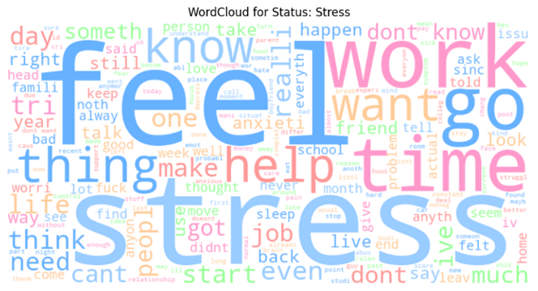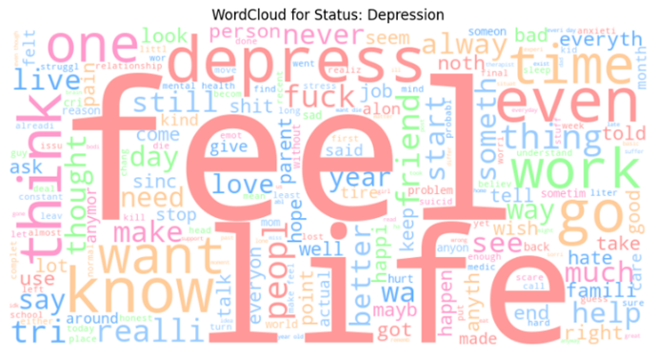

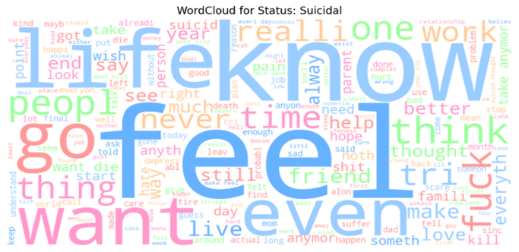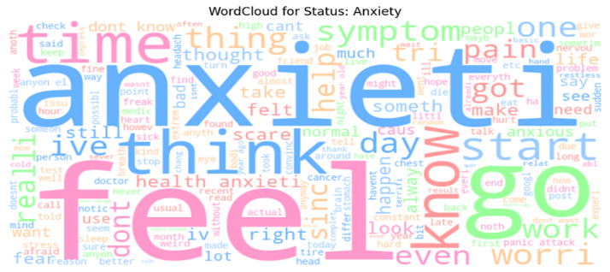

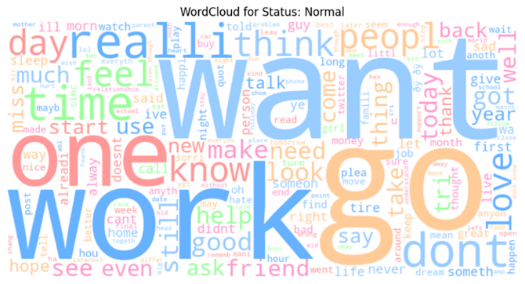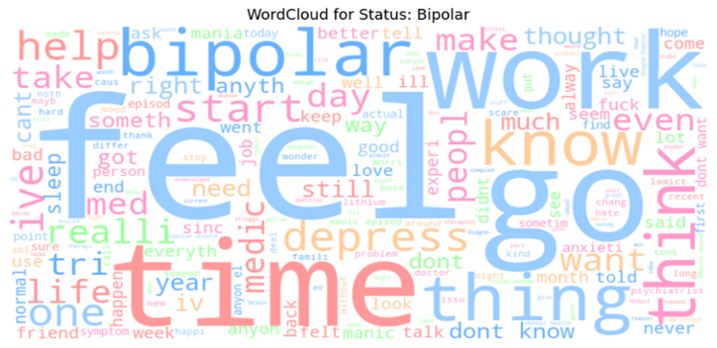

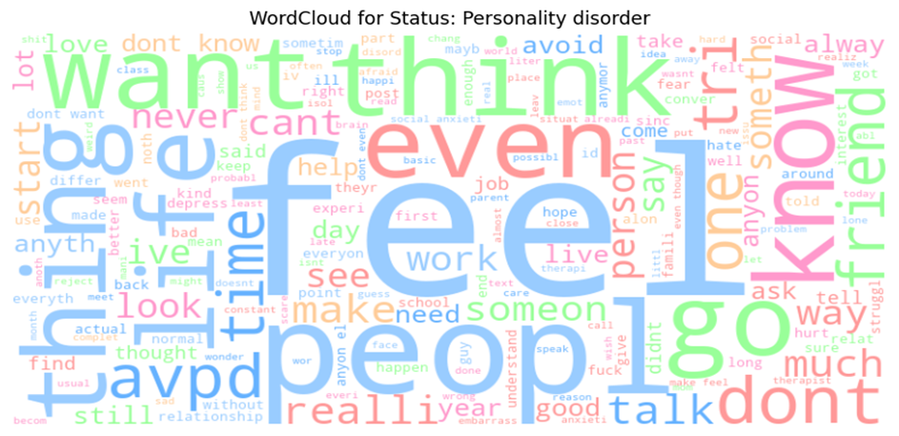

Subsequent to preprocessing, the textual data was transformed into a numerical format through vectorization using Term Frequency-Inverse Document Frequency (TF-IDF). This method quantifies the importance of words within the corpus, facilitating the application of machine learning algorithms. Given the class imbalance identified earlier, Random Oversampling was employed to ensure that minority classes like Personality Disorder and Suicidal received adequate representation during training, thereby mitigating potential biases.

The modeling phase encompassed both baseline and advanced machine learning algorithms, each selected for their unique strengths and suitability to the task at hand. Logistic Regression was chosen as a baseline model due to its simplicity, interpretability, and efficiency in handling binary and multi-class classification problems. Its ability to provide probabilistic interpretations of predictions makes it a valuable starting point for understanding the relationships within the data.

Naive Bayes, specifically the Multinomial Naive Bayes variant, was employed as another baseline model. This probabilistic classifier is particularly effective for text classification tasks due to its assumption of feature independence and its performance with high-dimensional data. Its simplicity and speed make it a practical choice for initial experimentation.

To capture more complex patterns within the data, Random Forest was introduced as an advanced model. As an ensemble learning method, Random Forest builds multiple decision trees and merges their results to improve predictive accuracy and control overfitting. Its robustness to class imbalance and ability to handle a large number of input features make it well-suited for the intricacies of mental health-related text data.

Support Vector Machines (SVM) were also utilized to explore their capability in finding optimal decision boundaries between classes. SVMs are renowned for their effectiveness in high-dimensional spaces and their versatility with different kernel functions, allowing them to model complex relationships within the data.

Each model was meticulously tuned using hyperparameter optimization techniques to enhance performance. For instance, the regularization parameter in Logistic Regression was adjusted to prevent overfitting, while the number of trees and depth in Random Forest were optimized to balance bias and variance. SVMs were experimented with different kernel types to identify the best fit for the dataset's underlying structure.

Evaluation metrics such as accuracy, precision, recall, and the F1-score were employed to assess model performance comprehensively. Accuracy provided an overall measure of correctness in predictions, while precision and recall offered insights into the models' ability to correctly identify positive instances and capture all relevant instances, respectively. The F1-score, being the harmonic mean of precision and recall, served as a balanced metric to evaluate the models' effectiveness, especially in the presence of class imbalance.

By leveraging this combination of baseline and advanced models, the project aimed to identify the most effective approaches for sentiment-based mental health classification, laying the groundwork for the development of intelligent tools capable of supporting mental health initiatives.

**Results**

Evaluating the various models on the dataset revealed clear performance distinctions and offered insights into their respective strengths and limitations. The final evaluation metrics for each model—Logistic Regression, Naive Bayes, Random Forest, and Support Vector Machine—were summarized using accuracy, precision, recall, and the F1-score. These metrics provide a comprehensive view of model performance, ensuring that both overall correctness and the model’s ability to correctly identify and capture each class are considered.

*Table 1: Performance metrics of the four model*

Logistic Regression emerged as the top-performing model, achieving an accuracy of approximately 77%. Its balance between precision and recall led to a strong F1-score as well. The model’s relative simplicity may have contributed to its stable performance, preventing overfitting and capturing generalizable patterns. This result suggests that while more complex models have the potential to model intricate relationships, simpler methods can sometimes be more effective, particularly when the data may contain noise or semantic overlap.

Naive Bayes, while fast and interpretable, struggled to differentiate between closely related mental health statuses, reflected in its lower accuracy and recall. Random Forest and Support Vector Machine, both considered more advanced models, performed comparably with accuracy and F1-scores around 74%. Though they did not surpass Logistic Regression, their results indicate that these methods were still reasonably effective, potentially benefiting from further hyperparameter tuning or richer feature representations.

The presented results underscore the complexity of sentiment analysis in the mental health domain. While accuracy values in the mid-70% range are promising, the challenges of distinguishing semantically similar categories (e.g., Anxiety and Stress) and addressing class imbalance remain. This table serves as a concise reference point, highlighting that progress has been made but that additional refinements, more data, and advanced NLP architectures may be needed to further enhance classification performance.

**Discussion**

The results of this project underscore several critical challenges and offer avenues for future improvement. One of the primary obstacles encountered was the semantic similarity between certain mental health conditions, particularly Anxiety and Stress. The linguistic overlap between these categories limited the model's ability to differentiate effectively, resulting in significant misclassification. This limitation points to the need for more nuanced approaches that can capture the subtle differences in language use associated with each condition.

Class imbalance remained a formidable challenge, as minority classes continued to exhibit lower recall rates despite the application of Random Oversampling. This persistent imbalance suggests that additional strategies, such as incorporating more diverse and representative data or employing more sophisticated resampling techniques, may be necessary to enhance model performance for underrepresented classes.

Model limitations were also evident, particularly with baseline models struggling to grasp the nuanced language features inherent in mental health-related text. While advanced models like Random Forest and SVM offered improved capabilities, they required meticulous hyperparameter tuning to prevent overfitting, further complicating the modeling process.

To address these challenges, several recommendations emerge. Incorporating Transformer-based models like BERT, which excel in capturing contextual nuances, could significantly enhance the model's ability to differentiate between semantically similar categories. Additionally, exploring attention mechanisms would allow models to focus on the most informative parts of the text, aiding in more accurate classification. Data augmentation strategies, including the acquisition of more real-world data for minority classes, would bolster training robustness and improve model generalization. Furthermore, implementing real-time adaptation through periodic model fine-tuning could help accommodate evolving language patterns in mental health discussions, ensuring that models remain relevant and effective over time.

The potential applications of this project are vast and impactful. Automated mental health monitoring systems could leverage the developed models to track and analyze mental health trends across social media platforms in real-time. Integration into support systems, such as chatbots, would enable personalized and empathetic interventions based on detected mental health signals, providing timely assistance to individuals in distress. Additionally, early diagnosis systems could utilize the models to flag potential mental health risks for further clinical evaluation, facilitating proactive support and resource allocation.

**Future Work**

Building upon the foundations laid by this project, several avenues for future work present themselves. Developing models using advanced Transformer architectures like BERT could significantly improve performance, especially in distinguishing between semantically overlapping categories. Expanding the dataset by partnering with mental health organizations would enhance model generalization and ensure a more balanced representation of all mental health conditions. Ethical considerations must remain at the forefront of future endeavors, necessitating the establishment of clear protocols for privacy and data security to ensure the responsible use of sensitive mental health data.

Moreover, expanding the project to encompass multilingual datasets would broaden its applicability, enabling support for diverse populations and enhancing the inclusivity of mental health tools. Cross-language models would allow for the analysis and classification of mental health statuses in multiple languages, addressing the needs of non-English speaking communities and fostering a more comprehensive approach to mental health support.

**Conclusion**

This study underscores the potential of sentiment analysis and machine learning in the realm of mental health classification. By meticulously preprocessing data, addressing class imbalance, and evaluating a spectrum of machine learning models, the project achieved a commendable accuracy rate with Logistic Regression. However, challenges such as semantic overlap between certain mental health conditions and persistent class imbalance highlight the need for ongoing refinement and innovation. The adoption of advanced natural language processing techniques, coupled with continuous data enrichment, holds promise for significant improvements in model performance and reliability. Ultimately, this project establishes a solid foundation for the development of automated tools that can support individuals and mental health professionals, contributing to more effective mental health care and intervention strategies.